Name Social Studies, Ch.3 Ancient Israel, Doc.

Date *Journey Across Time,* p90 Using Geography Skills

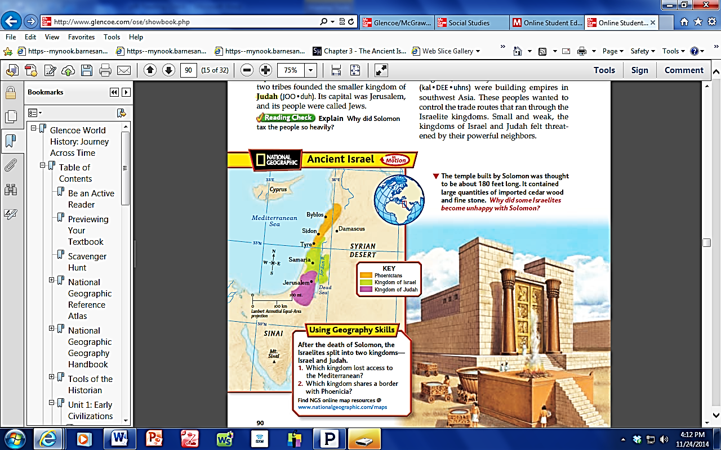

1. Which kingdom lost access to the Mediterranean?
2. Which kingdom shares a border with Phoenicia?
3. Use the map scale to determine how far it is from Byblos to Samaria:
4. What line of latitude runs closest to Tyre?
5. What line of longitude runs closest to Damascus?